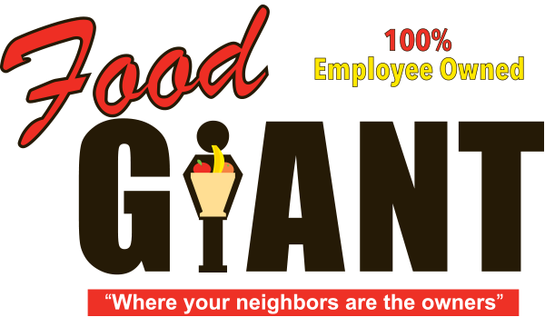

**COT 6931 Final Report**



Food Giant Sales Flyer Generator

**Student - Kendrick Hagerman**

**Client - John Webb**

**Date: 4/23/2017**

Contents

Acknowledgements 2

Project Summary 2

Main Body of Report 3

Project outputs and outcomes 3

How did you achieve the outputs and outcomes? 3

What did you learn? 3

Conclusions 4

Recommendations 4

References 4

Terms of Reference 4

# Acknowledgements

This project report was developed thanks to my client, John Webb, how provided me with a problem that I could solve for my Capstone, and provided me documents and pictures I would use for my layout. Also, this document was completed using documentation from the University of West Florida

# Project Summary

This project is for the Food Giant Supermarket company. The project’s objective is to earn more revenue for the store and reduce the cost of eliminating excess inventory before it loses the company income by becoming expired goods. This will be accomplished by creating a Graphical User Interface (GUI) program designed for District and Store Managers of the company. This program, named the Food Giant Flyer Creation program, will allow these Managers to generate customized flyers specifically for their store that they can print and distribute to customers. These flyers will contain information like the sale dates, store location, store phone number, and a list of items complete with their sale price. Currently, they have no way to create flyers in this fashion. Currently, the only way customers can find out about store-specific sales is to be at the store. These custom flyers will allow a store to more easily reach and inform their customer base about sales, which should draw in more customers, potentially increasing revenue. Finally, this program will be designed for Managers with very little experience with computers.

# Main Body of Report

## Project outputs and outcomes

The project is designed to allow a Manager to output a customized flyer based on one of many flyer templates. This flyer will contain one to fifteen user-selected items consisting of the item name, price, description, and an image of the product. This flyer will be savable as a Portable Document Format (PDF) or printable to a standard 8 1/2 by 11 (standard sheet) paper. The item name and image will be stored and read out of a SQL database. The project will also allow a Manager with appropriate permissions to enter in new store items into the SQL database.

The design phase of the project’s outcome ended with multiple deliverables. These deliverables are: a prototype of the full application, a Software Design Document (SDD), a Software Product Management Plan (SPMP), a schedule for the project (ending in August), a Coding Standards Document, a Software Test Document (STD), a Risk Management Document and a Software Requirement Specification (SRS). I also created a PowerPoint and YouTube presentation describing my design.

## How did you achieve the outputs and outcomes?

Once finding out about the project from my client, I discussed the initial problem and objective to better understand what their needs were. I wrote a very simple document containing basic requirements to verify I could actually complete what was being requested of me given my fixed Capstone Project duration. After verifying that I could accomplish the client’s requirements in this period, I then called my client back to accept this project. After accepting the project, I started working on the Project Definition, which lead to many various tasks being complete. I also turned the basic requirements I initially wrote into more detailed SRS items while I worked on my Project Definition. Next, I presented these requirements to the client via email to continue to verify I understood their needs.

As the client clarified these requirements, I decided to begin my Software Design Document and Test Cases. To gain a better understanding of how my design should be defined, I created multiple prototype applications. This in turn helped me figure out which components would be effective in my design, and allowed me to present my program to the client in order to better define my requirements. This process continued through multiple iterations until I defined my final design and requirements for the Capstone.

## What did you learn?

Working on the requirements, schedule, design, test cases and risks improved my Software Engineering skills. Combined with doing very similar documentation work at my job, I feel like I have improved my requirements elicitation, prototyping, documentation, and design skills greatly over the last few months. I feel very comfortable with engaging clients about software requirements and can quickly break down projects into at least large requirements that I can continue to break down into smaller requirements.

For this project, my programming goals are to improve my skills with Model View View-Model (MVVM) design, Caliburn Micro, ASP.Net and gain more experience in defining my software requirements and design. I feel like have already succeeded in all of these objectives but ASP.Net. I created an effective foundation and a reusable design template for other MVVM-focused designs using Caliburn Micro. I expect to continue to progress in my programming knowledge during the Implementation Phase.

I learned more about how to set up effective and efficient Bindings using the MVVM framework and improved my familiarity with XAML by creating many visual elements. Many parts of the MVVM and XAML have become less obfuscated to me, and I feel more comfortable with talking about the details of my MVVM projects to both coworkers and to clients.

# Conclusions

Overall, it has been a busy four months with work and full-time graduate school. However, I feel like I have drastically improved my software engineering skills. This flyer creation project is not guaranteed to be used by the company, and it is up to me to work with my client to deliver an application that is beneficial to the company and helps them to earn more revenue. No matter if the project succeeds or fails once it is deployed, I will still have learned a lot about software engineering.

# Recommendations

Please see the references for website links I would recommend looking at for more information.

# References

Microsoft. *The MVVM Pattern.* 2017 <https://msdn.microsoft.com/en-us/library/hh848246.aspx>

Caliburn Micro. *Caliburn.Micro Xaml made easy.* 2017 <http://caliburnmicro.com/>

## Terms of Reference

|  |  |
| --- | --- |
| Term | Definition |
| ASP.NET | Active Server Pages |
| ASPX | Active Server Page Extended |
| C# | C-Sharp Programming Language |
| GUI | Graphical User Interface |
| MVVM | Model View View-Model |
| QA | Quality Assurance |
| SDD | Software Design Description |
| SLN | Visual Studio Solution |
| SPMP | Software Project Management Plan |
| SQL | Structured Query Language |
| SRS | Software Requirements Specifications |
| STD | Software Test Document |
| VS | Visual Studio |
| XAML | Extensible Application Markup Language |